(Approx. 547 words)

How to Add Your Signature to Emails
By Nancy DeMarte, 2nd Vice President, Sarasota Technology Users Group, FL September 2017 issue, STUG Monitor
www.spcug.org
ndemarte (at) Verizon.net

If you send a lot of email messages, it can be a good idea to create one or more standard message signatures. These can be time-savers and can be personalized, depending on the audience; for instance, one for personal messages and one for work (or volunteering).

Message Signature:
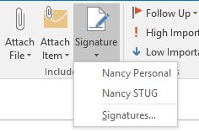
To create a message signature in Microsoft’s email app, Outlook, open a new message. Then, on the Message tab in the Include group, click Signature, then Signatures. Figure 1 shows this tool listing two signatures I created. I can choose which to include, depending on the purpose and recipient of the email message.
Figure 1- Message Signature icon in Outlook

When you click Signatures, a dialogue box opens (Figure 2). To add a new signature, click New in the “Select Signature to edit” box and type a name for it, as shown. In the “Choose default signature” section, choose the email account from which messages will be sent. You can have different signatures for different accounts. Click the v next to New Messages if you want the signature automatically attached to new emails. Do the same for Replies/forwards, if you wish. In the Edit signature box at the bottom, type your new Signature. Notice that you can edit it by changing the font or font size, color, and other properties. You can include as much information as you wish, like address, phone, etc. You can also add an image, like a photo or logo, using the next to last icon in the editing tools row or a hyperlink to a website like Facebook using the last icon in that row. When finished, click OK.
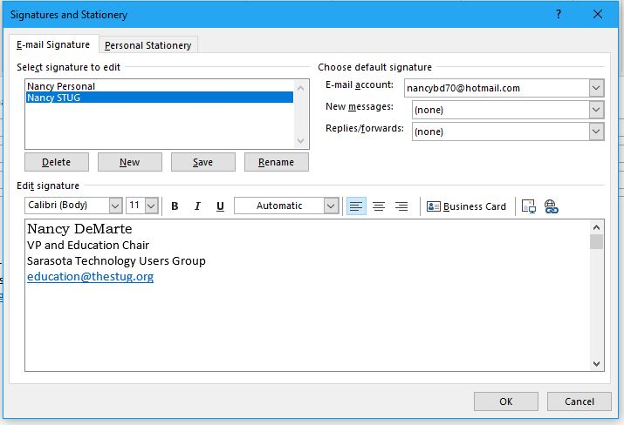

Figure 2 - Signature creation box in Outlook

Your signature will now appear at the end of all messages. If you prefer not to have it in every message, you can leave New Messages and Replies/forwards as (none). Then you can enter the signature in individual email messages by opening the message and clicking Signature in the Include group. Choose the name of the signature you want to include.

Add Signatures in Gmail:
Message signatures are available in many other email applications besides Outlook, including Gmail. To add a signature to Gmail messages, open Gmail and click the Settings gear shaped icon in the top right corner. (Figure 3).


Figure 3 Gmail settings gear icon

Scroll down the page until you come to Signature. Add your name and other details and click “Save Changes” at the bottom of the Settings page.

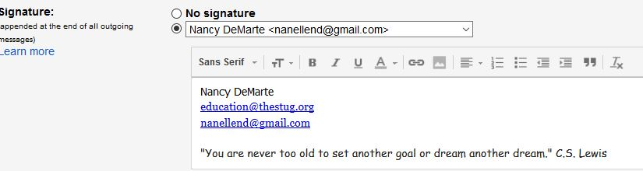
Figure 4 Gmail Signature setup box

Here are a couple of tips about adding a signature to Gmail.

1. If you make a mistake when formatting the signature, select the section that you need to change. Then click the icon at the right end of the formatting ribbon to clear all formatting for the selected text. When you get the signature information the way you want it, don’t forget to scroll to the bottom of the Settings page and click Save Changes.

2. Be cautious about what kind of information you include with your signature. There are always hackers looking for home addresses and phone numbers.

